INSTRUCTIONS

This project consist of server and mobile app. Server have to be first set up to run this project. The server source code is present at the directory “/Source Code/Server code” and the corresponding binary at “/executables/Server”

SERVER DEPLOYMENT

Server is already deployed on Openshift cloud platform at <http://student-cut.rhcloud.com/home>

Username : gaurav

Password : ankit

So if you want, you can skip the server deployment and continue with mobile app deployment.

There are 2 ways of deploying server

1. Importing MAVEN Project on eclipse
2. Importing Eclipse project

MAVEN PROJECT

For this,

* your computer must have maven installed and classpaths set.
* M2E plugin should be installed in eclipse.

After that in eclipse, Click File 🡪 import 🡪existing maven projects,

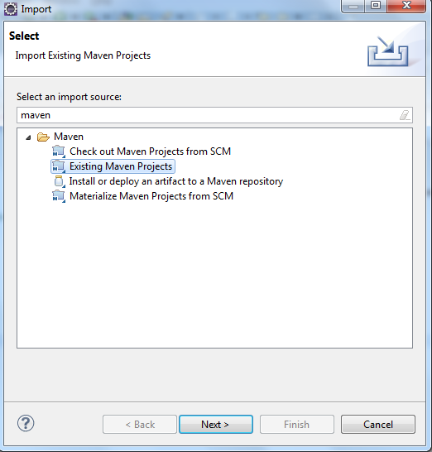

Then browse for “/Source Code/Server code/Maven Based”

OR if you do not want to do it with maven, then click on file🡪import🡪existing projects into workspace

Then browse for “/Source Code/Server code/Dynamic Web Project”

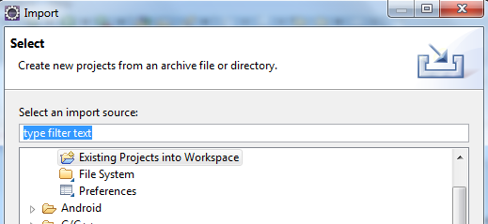

After the project gets imported, **edit datasource.xml**

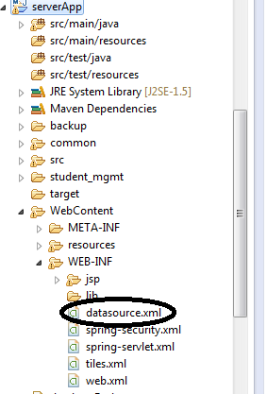

**Edit two line in the xml,**

The first line inside <property name=”url”> is for the database url which should be set to **“/Database/apache derby database/student_mgmt”**

**Remember these are forward slashes even for windows OS**

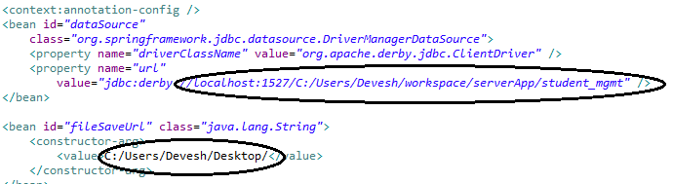

The second path is for the path where file uploaded by the teacher will be saved

**Remembet to add ‘ / ’ after selecting the directory.**

After the project gets loaded, right click it 🡪 run on server

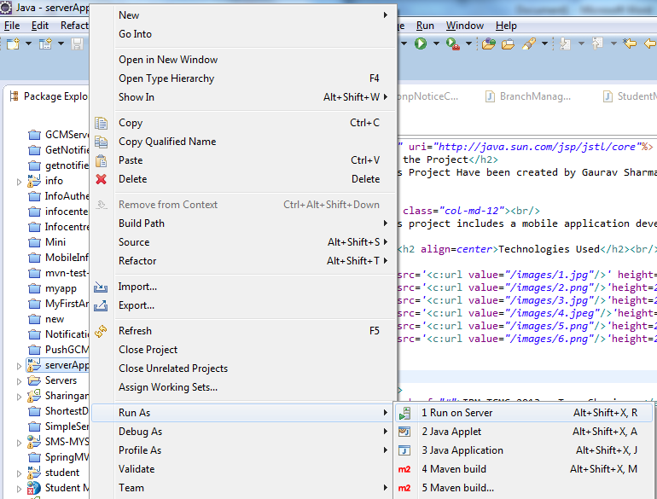

Then select Worklight server

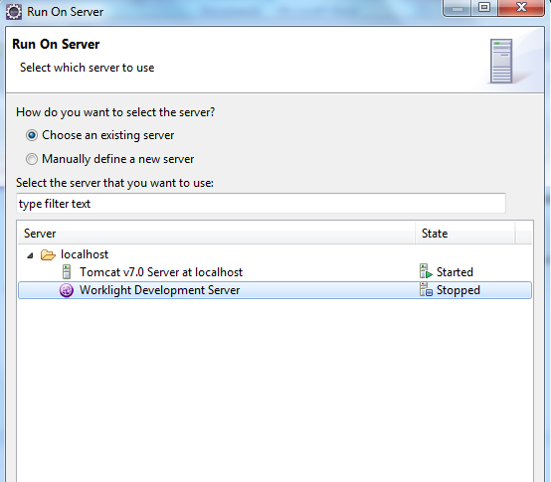

The server is Done, Check by running it in browser.

Username : gaurav

Password : ankit

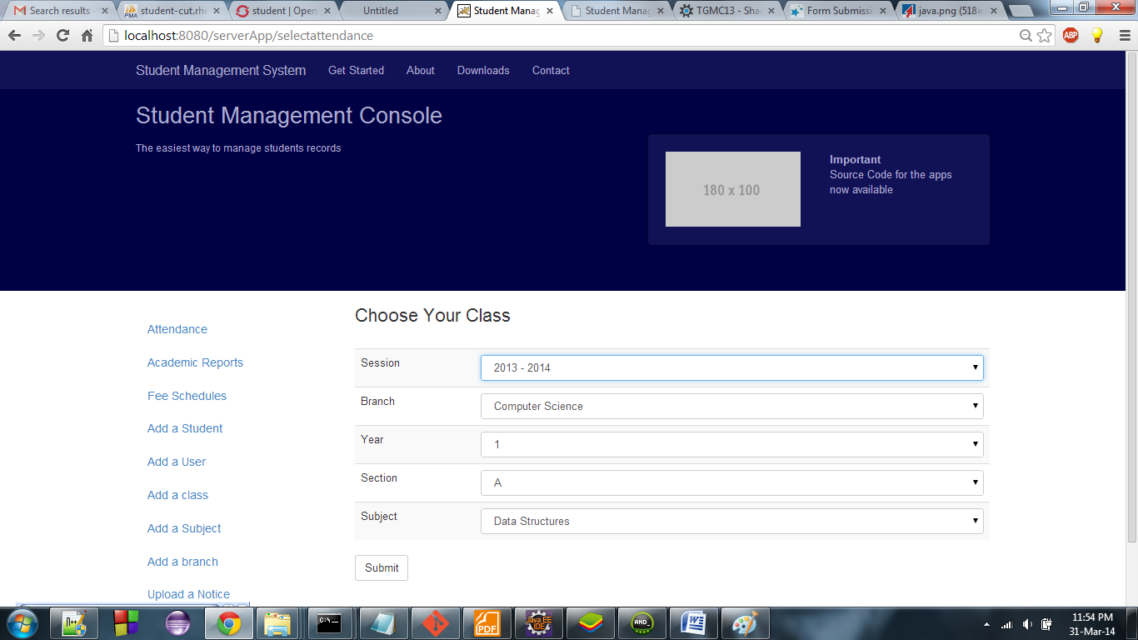

SETTING UP MOBILE APPLICATION

Import the project in eclipse

If you are using the existing cloud server on openshift(URL mentioned above), then there is no need to modify url.js, just execute the apk or compile using the source.

Otherwise if you are running the server on your own,

Go inside apps 🡪StudentManagementSystem🡪common🡪js🡪url.js

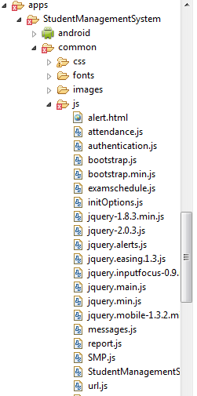

Edit the first line to your server address(ex – **192.168.1.1:8080/serverApp**)

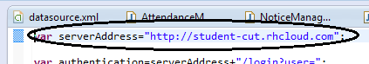

**Do not put forward slash after server address‘ / ‘ **

**Do not put **locolhost** or **127.0.0.1** address**

Compile for android and run

Username for mobile App – 1109113049

Password --1109113019

PROJECT TEAM 🡪 Sharingan

Members 🡪

Gaurav Sharma

Ankit Chaurasia